

Northway School

Northway School Mill Hill Site
KS2
Northway School, The Fairway, Mill Hill, NW7 3HS
Northway Secondary,
KS3 & KS4
Northway School, Pursley Road, Mill Hill, NW7 2BU
Northway Infants, High Barnet Site
Reception & KS1
Northway School, Grasvenor Avenue, High Barnet, EN5 2BY

AUTOMATIC EXTERNAL DIFIBRILLATOR POLICY

ASTHMA POLICY

ANAPHYLAXIS POLICY

EPILEPSY POLICY

NORTHWAY SCHOOL
AUTOMATIC EXTERNAL DEFIBRILLATOR (AED) POLICY
Early defibrillation is recognised as a significant factor in a person’s survival following sudden cardiac arrest.
An automatic external defibrillator (AED) is a portable device designed to be used by members of the public and are very effective at guiding the operator through the process of administering a shock if required. They have become widely available, are safe and easy to use and will not allow a shock to be given to a casualty who does not require one.
The purpose of this policy and procedure is to help school staff understand:
- When to use the AED
- What their role is in an emergency situation
- How to check and maintain the AED

What is an AED?
- An AED is a device that is used during a sudden cardiac arrest (SCA)
- Analyses the victim’s heart rhythm
- Determines if a shock is required
- Provides voice and/or visual prompts to assist the rescuer.
- An AED is a temporary lifesaving device that is intended for use prior to the arrival of Emergency Medical Services.

Location and description of AED:
The AEDs at Northway School are located in the First Aid Rooms and are is suitable for use by both adult and children over 1 year old. It has pre-connected dual electrode pads that can be used on both adult and children. For child use the device can be easily switched to paediatric mode.
Additional equipment in the AED case includes a resuscitation disposable face shield, protective glasses, scissors, disposable razor, disposable gloves and patient wipe, and spare adult electrode pads.
Training
The majority of staff at Northway School have attended and hold a ‘First Aid at Work’ or ‘Paediatric First Aid’ qualifications. These courses and subsequent refresher courses include use of AED’s and practice runs with ’training AED’s’.
ADULT Procedure for suspected sudden cardiac arrest (SCA) and use of the AED:
- Ensure it is safe to approach the casualty.
- Promptly assess the casualty for response and tilt head back to open airway to determine if they are breathing normally. Call for help.
- For the casualty who is unresponsive and not breathing normally:
  - Dial 999 and ask for an ambulance stating patient’s condition.
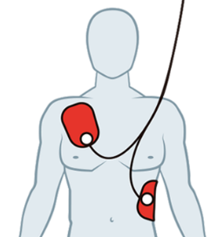
  - Start cardio-pulmonary resuscitation (CPR) and send for the AED as soon as possible.
  - For an adult start CPR with 30 chest compressions followed by 2 rescue breaths and continue
  - When the AED arrives, switch it on and follow the verbal instructions. Place pads as per illustration. Dry chest if necessary.
  - Minimise interruptions to CPR when attaching the AED pads to the casualty.
- Do not stop CPR unless you are certain the casualty has recovered and is breathing normally or a health professional tells you to stop, or the AED requests you to stop so that heart rate and rhythm can be analysed.
CHILD Procedure
The same steps can be followed for resuscitation of children with the following modifications:
- Give 5 initial rescue breaths before starting chest compression.
- If you are on your own, perform CPR for 1 min before going for help.
- Compress the chest by at least one-third of its depth, approximately 4 cm for an infant and approximately 5 cm for an older child. Use two fingers for an infant under 1 year; use one or two hands for a child to achieve an adequate depth of compression. AED only to be used on those children over 1 year. For those children 8 years and under place one pad on the front of the chest and one on the back, as per illustration to avoid contact between the two pads. Place switch on the front of AED to paediatric mode.
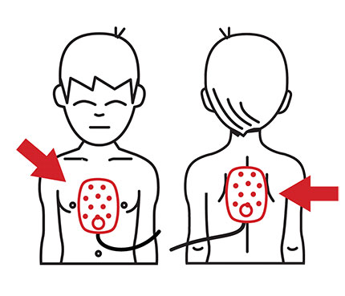

Covid 19 advice
To reduce the risk of virus transmission it is highly advisable to use a resuscitation face shield and protective eye wear and gloves, all available from AED bag. Proper disposal of PPE and thorough washing of hands afterwards should be carried out. If there is a perceived risk of infection rescuers should seek advice from SMT and NHS 111 advice service.

Maintenance
School AEDs self-check daily, and have a status LCD display. The display shows: the status of the unit; the connection status of the electrode pads and expiration of the electrode pads and battery.
The status LCD is visible through the carry bag and is checked weekly. A circle denotes the AED is fully functional, a cross denotes there is a fault. Battery and pad expiration denoted by their individual symbols.
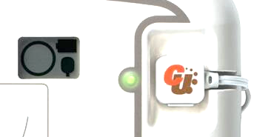

Presence of accessory pack also to be checked at this time.
For AED IPAD SP1 model technical support call CU Medical Systems 03333 444789 or info@ipad-aed.com.
For Mediana AED contact info@mediana.co.kr

Post incident procedure
Check battery and seek advice from supplier.
Replace used pads
Replace used items from additional equipment pack –disposable face mask/shield, scissors, disposable razor, disposable gloves and patient wipe.
Record details of the incident in the Accident/ incident book, and RIDDOR if applicable.
Report use of AED to school/ borough Health and Safety Officer
If available download and transfer data from the AED, if requested by ambulance service.

References

    - British Heart Foundation website
    - Department for Education Automatic External Defibrillators (AEDs). A Guide for Schools (February 2018)

NORTHWAY SCHOOL
ASTHMA POLICY
Northway School recognises that asthma is a widespread, serious but manageable condition affecting a number of children at school. We welcome all pupils with asthma and aim to support these children in participating fully in all aspects of school life. We endeavour to do this by:
- Ensuring all staff who have pupils with asthma in their care know who those pupils are and know the school’s procedure to follow in the event of an asthma attack.
- Ensuring that children have access to their reliever medication immediately when needed. Staff should ensure that these medications accompany the child for all activities around the school and particularly when outside the school premises and during a fire drill.
- Keeping records and ensuring pupils have an up to date asthma care plan including medicines they take and any known triggers.
- The school has an emergency salbutamol inhaler and asthma kit located in the first aid room.
- Promote asthma awareness.
- The school environment, as far as possible, is kept free of the most common allergens that may trigger an asthma attack. For example, smoking and vaping are explicitly prohibited on the school site.
- The school asthma policy is reviewed regularly and asthma training attended by staff annually
- A list / register of medical conditions is held by each class and up dated as necessary.

Parent/Guardian responsibilities
It is the responsibility of the parent(s)/ guardian(s) to:
- inform us if a child suffers from or develops asthma;
- ensure that the child is provided with appropriate medication and spacer, in date and prescribed to the child with a pharmacy label, and the appropriate action (action plan from GP) for its use;
- ensure that there is sufficient medication in the inhaler(s) and that they are not being used beyond their shelf life;
- notify us of any change in medication or condition;
- inform us if sleepless nights/ school absences have occurred because of asthma;
- inhalers/spacers are regularly checked and cleaned.
- Permission from the parents / carers for the emergency salbutamol inhaler to be used if the child’s inhaler is broken, out of date, empty or missing.
- Children should not bring their preventer inhaler to school as it should be taken regularly as prescribed (usually morning and night). However, if the pupil is going on a residential trip, we are aware that they will need to take the inhaler with them so they can continue taking their inhaler as prescribed.

Staff training
Staff will attend asthma updates and training annually. This training will be provided by the school nursing team.
Staff who have had asthma training, and are happy to support children with their medical needs, need to supervise children to ensure they take their inhaler correctly. Inhaler use need to be recorded, and how effective treatment has been. Parents need to be informed of inhaler use.
We recognise that if asthma is impacting on a pupil’s life, and they are unable to take part in activities; requiring their reliever inhaler at school more than twice a week; tired during the day; or falling behind in lessons we will discuss this with parents/carers, and the school nurse, and suggest they make an appointment with their asthma nurse/doctor
School Environment
The school does all that it can to ensure the school environment is favourable to pupils with asthma. The school has a no-smoking policy. Pupil’s asthma triggers will be recorded as part of their asthma care plan, and where possible, the school will ensure that pupil’s will not come into contact with their triggers.
We are aware that triggers can include:
- Colds and infections
- Pollen, spores and moulds
- Dust and house dust mite
- Feathers and furry animals
- Exercise
- Stress, anger
- Cold air, change in the weather
- Chemicals, glue, paint, aerosols
- Food allergies
- Fumes and cigarette smoke (Source: Asthma UK)

As part of our responsibility to ensure all children are kept safe within the school grounds and on trips away, a risk assessment will be performed by staff. These risk assessments will establish asthma triggers which the children could be exposed to and plans will be put in place to ensure these triggers are avoided, where possible.

Taking part in sports, games and activities is an essential part of school life for all pupils. Pupils with asthma are encouraged to participate fully in all activities. All staff will know which children in their class have asthma, and if a pupil needs to use their inhaler before or during a lesson they will be encouraged to do so.

Emergency Salbutamol inhaler
As a school we are aware of the guidance ‘The use of emergency salbutamol inhalers in schools from the Department of Health’ (March, 2015) (www.schoolwellbeing.co.uk/uploads/chronicler/document/document/706/DoH_Guidance.pdf)
Our emergency Asthma Kit is kept in the first aid room. Disposable spacers are available, or plastic spacers and mask if used, will be sterilised between each use.
Covid 19 advice
Staff are advised to follow first aid guidelines regarding minimising risk for viral transmission and wear PPE for hands on care as per First aid guidelines.
Asthma Attacks
Our aim is to support pupils with their asthma and prevent them from having an asthma attack. However, in the event of an asthma attack occurring
Common ‘day to day’ symptoms of asthma are:
• Cough and wheeze (a ‘whistle’ heard on breathing out)
• Shortness of breath when exercising
• Intermittent cough
These symptoms are usually responsive to use of their own inhaler and rest (e.g. stopping exercise). They would not usually require the child to be sent home from school or to need urgent medical attention.
Signs of an asthma attack include:
• Persistent cough (when at rest)
• A wheezing sound coming from the chest (when at rest)
• Being unusually quiet
• Shortness of breath at rest, feeling tight in the chest
• Difficulty in breathing and nasal flaring
• Being unable to complete sentences and appearing exhausted
• A blue / white tinge around the lips
If a child is displaying the above signs of an asthma attack, the guidance below on responding to an asthma attack should be followed.
CALL AN AMBULANCE IMMEDIATELY AND COMMENCE THE ASTHMA ATTACK PROCEDURE (AS PER CHILD’S IHP) WITHOUT DELAY IF THE CHILD
• Appears exhausted •Has a blue/white tinge around lips
• Is going blue • Has collapsed

Responding to signs of an asthma attack –follow child’s IHP guidance
NHS Asthma attack procedure is as follows
- Keep calm and reassure the child. Follow child’s healthcare plan.
- Encourage the child to sit up and slightly forward. Remain with the child
- The inhaler should be shaken thoroughly before use.
- Use the child’s own inhaler – if not available, use the emergency inhaler and spacer
- Immediately help the child to take two separate puffs of the salbutamol via the spacer (60 seconds between each puff)
- If there is no immediate improvement, continue, as above. Give two puffs every two minutes up to a maximum of 10 puffs, or until their symptoms improve. • Stay calm and reassure the child. Stay with the child until they feel better. The child can return to school activities when they feel better
- If the child does not feel better or you are worried at ANYTIME before you have reached 10 puffs, CALL 999 FOR AN AMBULANCE. Child’s parents or carers should be contacted.
- If an ambulance does not arrive in 10 minutes give another 10 puffs in the same way.
- A member of staff should always accompany a child taken to hospital by ambulance and stay with them until a parent or carer arrives.
Use of the emergency inhaler or child’s own inhaler should be recorded. This should include where and when the attack took place (e.g., PE lesson, playground, classroom), how much medication was given, and by whom. The child’s parents must be informed.

References
- Asthma UK website (2015)
- Asthma UK (2006) School Policy Guidelines.
- Department of Health (2014) Guidance on the use of emergency salbutamol inhaler in schools

NORTHWAY SCHOOL
ANAPHYLAXIS AND ADRENALINE AUTO-INJECTOR POLICY
Northway School aims to provide a safe environment for staff and pupils who are at risk of severe allergic reactions.
We endeavour to do this by:
- Ensuring all staff who have pupils with allergies in their care, know who those pupils are and know the school’s procedure to follow in the event of an allergic reaction and anaphylaxis.
- All children with diagnosed allergies should have immediate access to their antihistamine and/or adrenaline auto-injector at all times. Staff should ensure that these medications accompany the child for all activities around the school and particularly when outside the school premises and during a fire drill.
- Northway undertakes to ensure that anyone suffering a severe allergic reaction (anaphylaxis) will be treated promptly, and an immediate 999 call for an ambulance will be made.
- Keeping records and ensuring pupils have an up to date healthcare plan, drawn up by the school nurse, stating known allergens and management of allergic reactions and anaphylaxis.
- The school has two spare emergency adrenaline auto-injectors located in the first aid room.
- Northway School cannot guarantee a completely allergen free environment, but will work hard to minimise the risk of exposure.
- Promote awareness of management of allergies and anaphylaxis.
- The school anaphylaxis policy is reviewed regularly and training attended by staff annually.

Parent/Guardian responsibilities
It is the responsibility of the parent(s)/ guardian(s) to:
- Inform us if a child suffers from allergies and provide information to the school nurse so that a Healthcare Plan can be drawn up
- Ensure that the child is provided with an action plan from the GP, medication is in date and prescribed to the child with a pharmacy label. If prescribed, two auto-injectors need to be available for use in school for this child.
- Notify us of any change in medication or allergy condition, or if the child has suffered a recent allergic reaction.

Emergency Adrenaline auto-injectors (AAI)
As a school we are aware of the guidance ‘The use of adrenaline auto-injectors in schools from the Department of Health’ (September 2017)
This states that:
- Schools may administer their “spare” adrenaline auto-injector (AAI), obtained, without prescription, for use in emergencies, if available, but only to a pupil at risk of anaphylaxis, where both medical authorisation and/or written parental consent for use of the spare AAI has been provided.
- The school’s spare AAI can be administered to a pupil whose own prescribed AAI cannot be administered correctly without delay.
- AAIs can be used through clothes and should be injected into the upper outer thigh in line with the instructions provided by the manufacturer.
- If someone appears to be having a severe allergic reaction (anaphylaxis), you MUST call 999 without delay, even if they have already used their own AAI device, or a spare AAI.
- In the event of a possible severe allergic reaction in a pupil who does not meet these criteria, emergency services (999) should be contacted and advice sought from them as to whether administration of the spare emergency AAI is appropriate.
These guidelines and other issues regarding school management of AAI’s can be found in the following DoH document
(www.gov.uk/government/publications/using-emergency-adrenaline-auto-injectors-in-schools)
- Our emergency adrenaline auto-injectors x2 are kept in the first aid room.
- Staff attend Anaphylaxis and use of AAIs annually. This training is provided by the school nursing team

Covid 19 advice
Staff are advised to follow first aid guidelines regarding minimising risk for viral transmission and wear PPE for hands on care as per First aid guidelines

Responding to symptoms of an allergic reaction
See flow chart
References
- Department of Health (2017) Guidance on the use of emergency adrenaline auto-injectors in schools

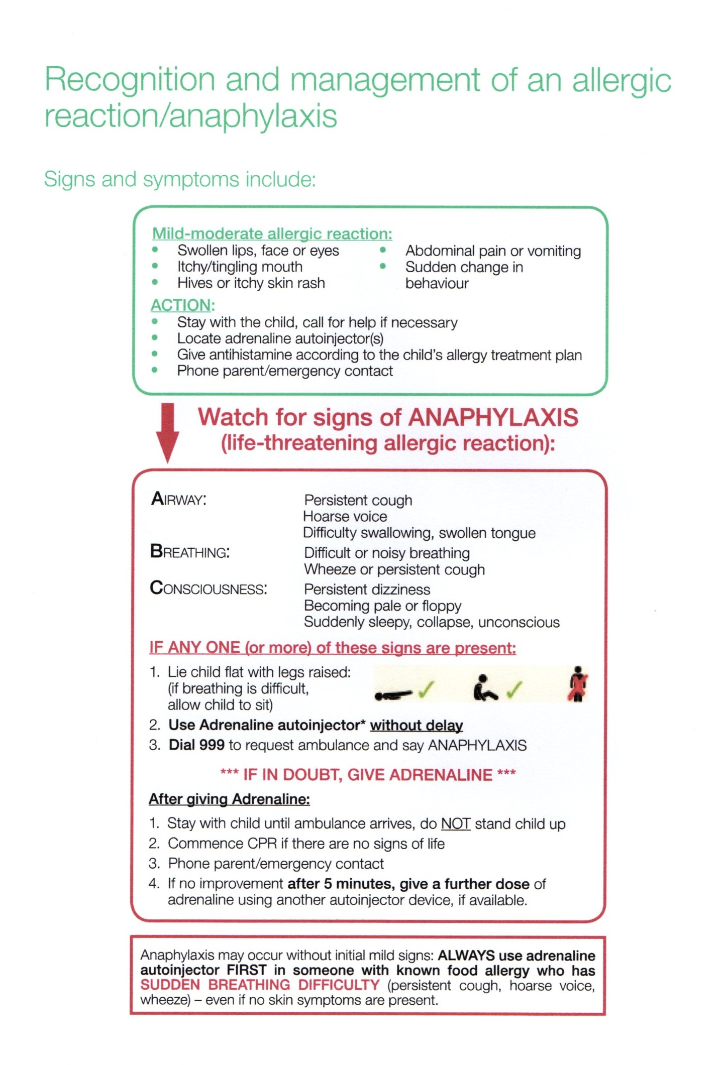
NORTHWAY SCHOOL EPILEPSY POLICY
Northway School aims to provide a safe environment for staff and pupils who suffer from Epilepsy.
We endeavour to do this by:
- Ensuring all staff who have pupils with Epilepsy in their care, know who those pupils are and know the school’s procedure and child’s healthcare plan, to follow in the event of an epileptic seizure.
- For those children with emergency epileptic rescue medicine, staff should ensure that these medications accompany the child for all activities around the school and particularly when outside the school premises and during a fire drill.
- Northway undertakes to ensure that anyone suffering a seizure will be treated promptly, and an immediate 999 call for an ambulance will be made.
- Keeping records and ensuring pupils have an up-to-date healthcare plan, drawn up by the school nurse, stating management of seizure.
- The school epilepsy policy is reviewed regularly and training attended by staff annually.

Parent/Guardian responsibilities
- Inform us if a child suffers from seizures and provide information to the school nurse so that a Healthcare Plan can be drawn up
- Ensure that the child is provided with an action plan from the GP. If medication is prescribed it is in date and prescribed to the child with a pharmacy label.
- Notify us of any change in medication.

First Aid for Seizures
Convulsive Seizures:
- Do not move the child/ person during the seizure unless in danger
- Do not put anything between the teeth
- Do not restrict their movement
- Do not give anything to eat or drink until fully conscious
- Do protect their head from injury by carefully placing something soft under their head
- Do turn them onto their side, into the recovery position as soon as the jerking stops or earlier if breathing is difficult or if they have vomited.
- Do stay with them until they have fully recovered, and provide reassurance
- Time length of seizure, follow Healthcare Plan and record and inform parents/guardians.
- Administer Buccal Midazolam if prescribed and as per IHP
- Call ambulance if: the seizure lasts longer than 5 minutes (or before if IHP states this); if one seizure follows another without recovery; if the person is injured; or if they have difficulty breathing; if this is their first seizure; or if Buccal Midazolam has been administered.

Non - Convulsive Seizures:
- Do not try to stop the seizure
- Guide away from Danger
- Be understanding and talk reassuringly throughout the seizure
- Repeat any instructions / information which may have been missed
- Time length of seizure, follow Healthcare Plan and record and inform parents/guardians.

